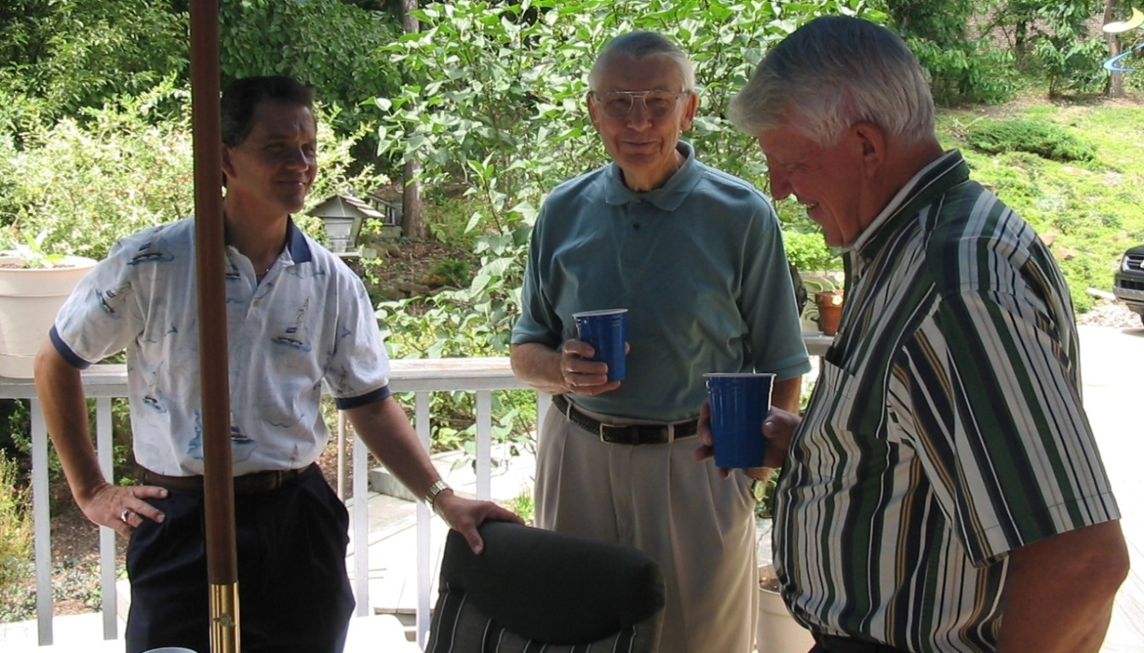

Larry Johnson, Roger Wolfe, David List - 30 July 2004

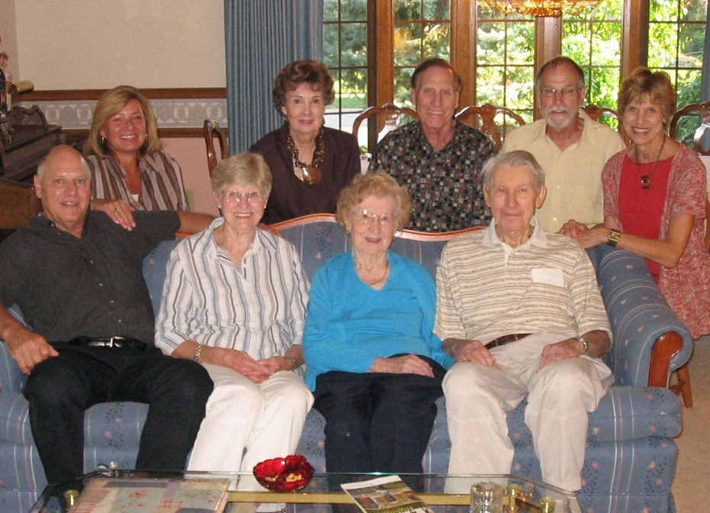

Back row: Tamey, Marg, Phil, Nelson, Mary Jo

Front row: John, Lois, Garnet & Roger Wolfe – 2008